AT3 Development of AR Interface Application

KIT208, Joshua Crisford, ID:574082

### Overview

This report describes the development of an Augmented Reality (AR) application that allows users to explore and interact with a 3D representation of the solar system. Users can rotate, scale, and learn about each planet while viewing their relative sizes and orbits. The goal of the project is to provide an educational tool that improves users’ understanding of the solar system by providing an immersive and interactive experience.

[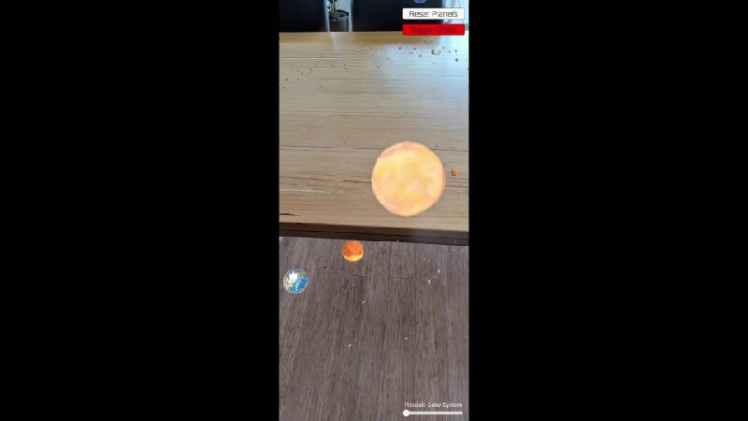](https://universitytasmania-my.sharepoint.com/:v:/g/personal/jc101_utas_edu_au/Eec55obtK8NGlVXrGc_N9sMB36UYMSmcyJmQsTN3qTMrMw?e=TIMvMm)

*(if you cannot play the video there is an alternate link at the bottom of the document)*

This application leverages the capability of AR to overlay digital content onto the physical world. This allows users to better grasp complex concepts, in this case planetary scale and orbit mechanics. By viewing these objects in their immediate environment, users have the opportunity to gain a clearer perspective into the vastness of space. Interactive features further enhance the learning process by making abstract concepts more understandable. This combination of real-world interaction and digital content creates a unique, immersive, and fun learning experience that traditional 2D media cannot offer.

### Description of the Application

#### What it does:

The AR solar system application allows users to view and interact with a 3D model of the solar system. Rotating and rescaling individual planets and displaying information about them are the primary interactions. In addition to interacting with individual planets, the application includes a rescaling slider that allows users to adjust the entire solar system to better fit their physical surroundings. There are also two overlay buttons, one stops the planets orbiting around the sun, the other resets all planets scale and rotation. The application is designed for educational purposes, particularly for students studying astronomy, offering a visual and interactive way to explore the solar system that is configurable to the individual user’s needs.

#### Significance of the Application:

The application offers an immersive experience that helps users understand the significant difference in the scale and movement of planets. Users can better appreciate planetary sizes and distance through direct interaction, which is challenging to convey using traditional 2D images or textbooks. The interactive nature of the application enhances learning, making it a useful educational tool for teaching about the solar system. The rescaling feature further lends to its usefulness in education. It is especially useful when demonstrating the vast differences in planetary size. By giving users control over scale, the application helps users to visualise how planetary systems relate to one another.

#### Significance of AR Technology:

Augmented Reality technology is ideal for this application because it allows users to view and interact with the solar system in their physical environment. AR offers a unique learning experience by integrating digital elements into the real world. This approach engages users more than static images or videos by providing a hands-on way to explore the solar system. AR also allows users to interact with these objects from multiple perspectives, improving spatial understanding. The immersive nature of AR can make complex astronomical concepts, such as orbits and distances, easier to understand by presenting them in a real-world context.

### Interaction Design

The interactions in this AR solar system application are essential for creating an engaging and educational experience. The following explains each key interaction:

#### Planet Rotation:

*Purpose:* Allows users to rotate individual planets, providing the freedom to view each planet from different angles and fully appreciate its details.

*Significance:* This interaction offers a more engaging experience to study planets compared with traditional 2D images, allowing users to fully explore unique planetary features in 3D.

#### Planet Scaling:

*Purpose:* Users can scale individual planets which increases or decreases its size to better demonstrate its dimensions relative to others, allowing a more focused exploration of unique planetary features.

*Significance:* Scaling planets develops understanding of planets’ size differences. This hands-on way of displaying vast size differences is significantly more difficult to convey when compared to static visuals.

#### Displaying Planet Information:

*Purpose:* When a user double taps on a planet, detailed information about that planet is presented. This enhances the educational value by providing key facts and significant data.

*Significance:* This interaction combines both visual exploration and informative data which works together to enhance engagement and learning outcomes for users.

#### Pause Orbit Movement:

*Purpose:* The ability to pause the planets orbits allows users time to explore the solar system in more depth without being distracted by the motion.

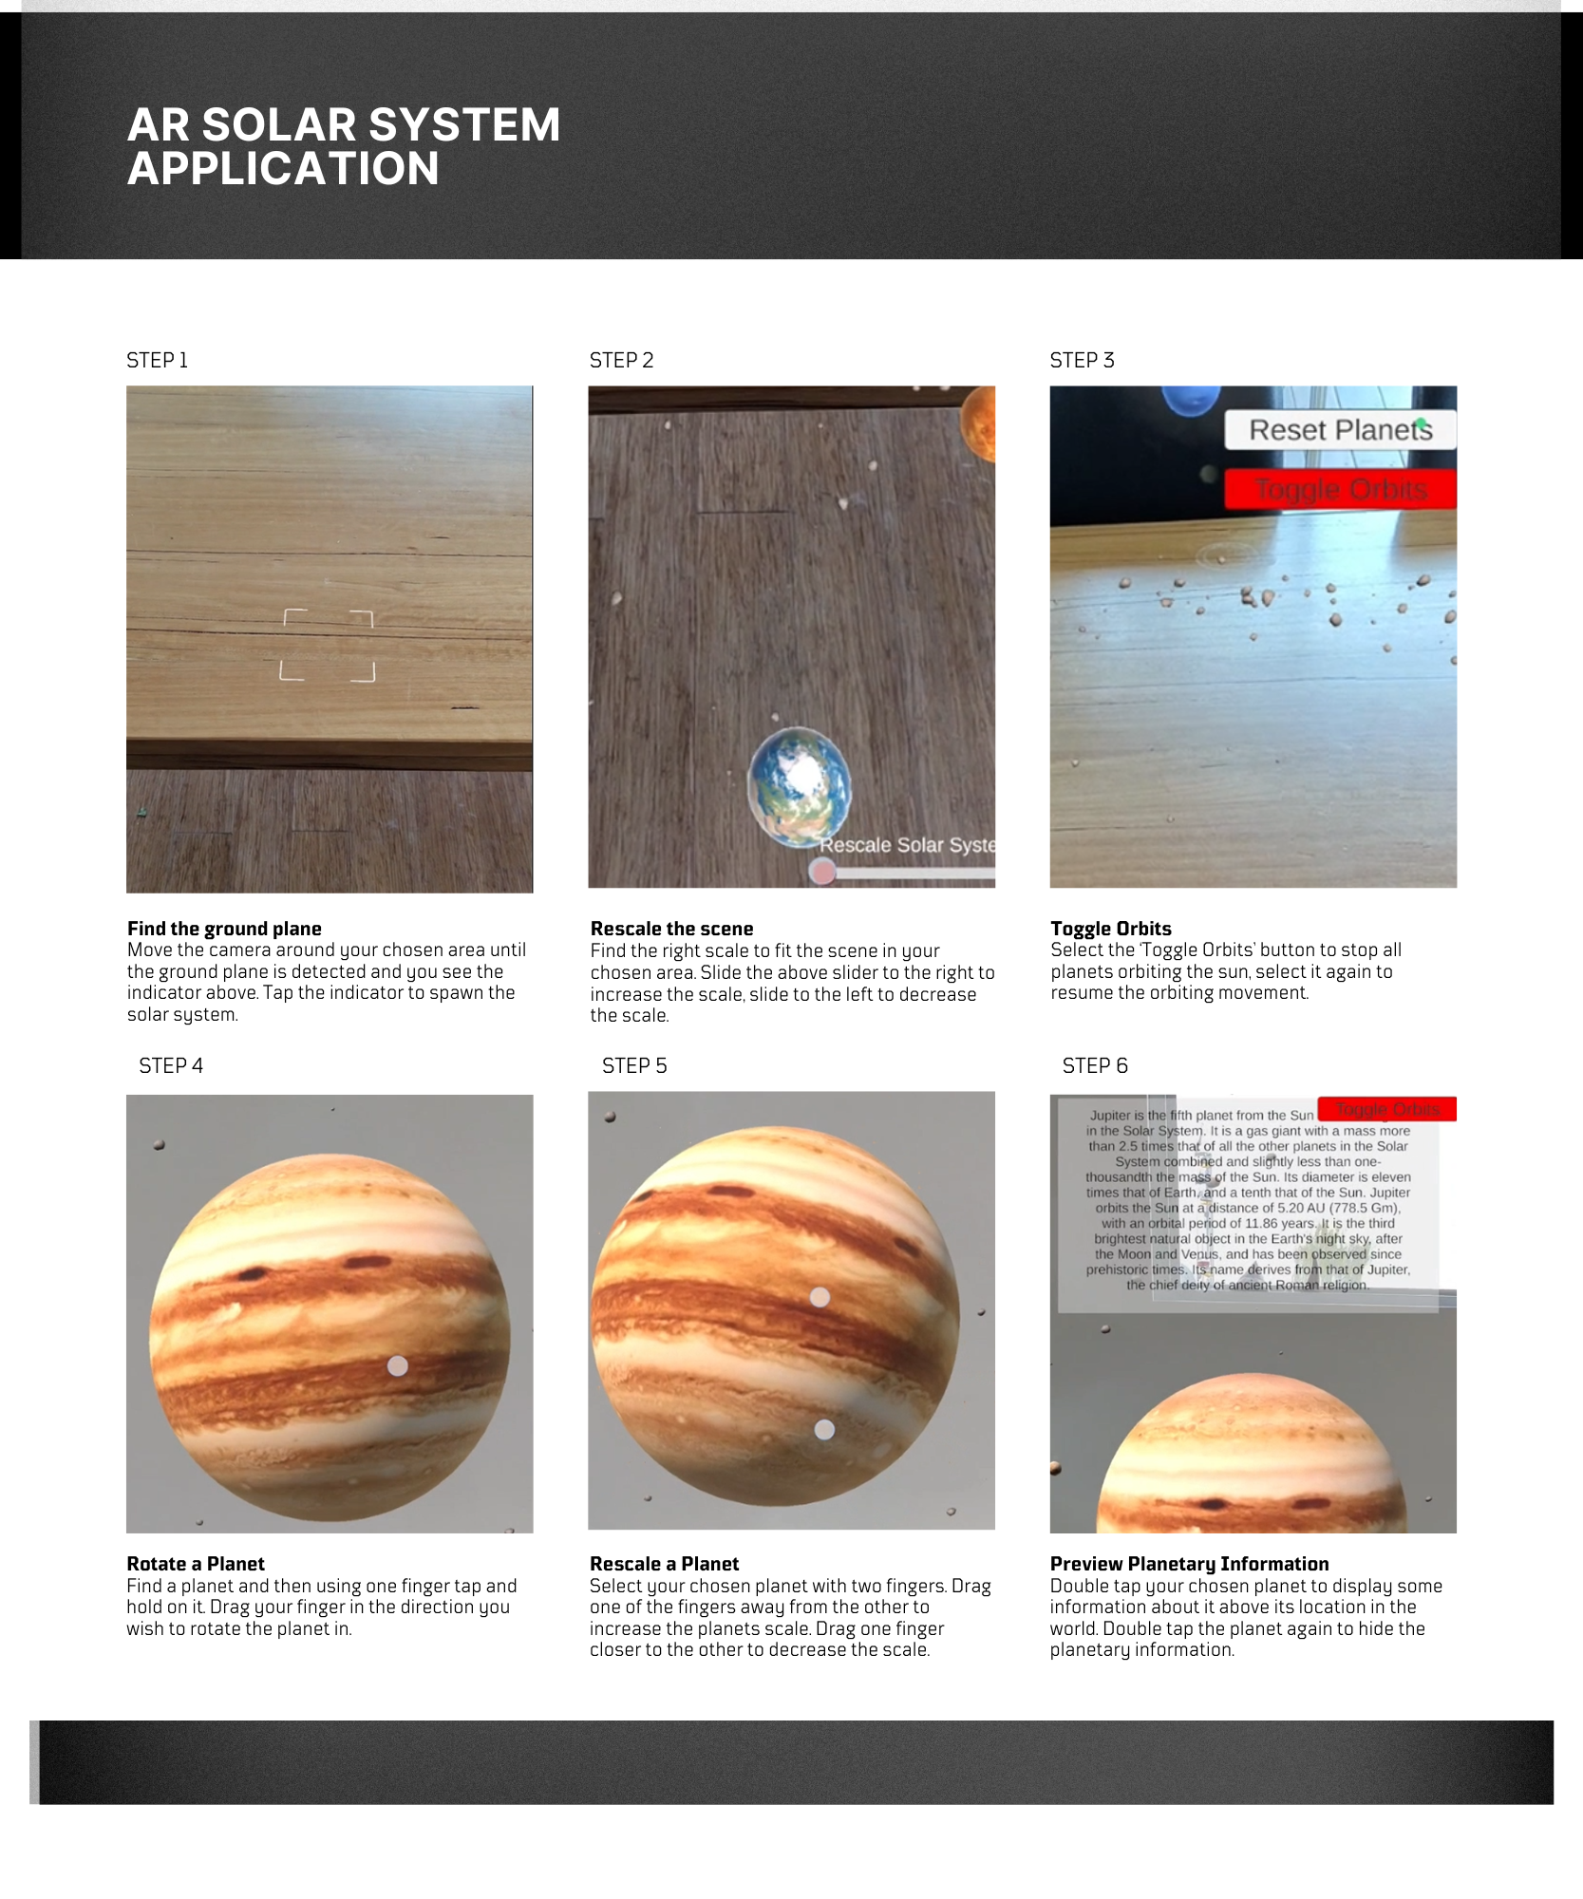*Significance:* This interaction gives users control over the learning process, allowing them to focus on specific planets or other interactions as they see fit.

### Technical Development

The AR solar system application was developed using the Unity engine with the Vuforia SDK for the AR functionality. Interactions were implemented using custom C# scripts that enable touch input for rotating and scaling planets, as well as toggling planetary information. Below is a breakdown of key technical aspects:

#### Interface Technology:

The Vuforia SDK is utilised for AR tracking, specifically using ground plane detection to anchor the solar system with the chosen environment. This allows users to place the solar system on any flat surface, such as a table, desk, or floor, and interact with it as if it exists physically in the space. The Unity engine was used to create the world scene and build the app on mobile platforms.

#### User Engagement and Interaction:

Users engage with the solar system completely through touch-based interaction. Each planet can be selected, scaled, or rotated using touch gestures. When a planet is double tapped, information is displayed via a world space UI, and then can be double tapped again to hide the UI. The UI tracks where the user is viewing it from and will reposition itself to ensure it can be read anywhere. These interactions allow users to manipulate planets directly with their fingers, promoting immersion and understanding.

* Scaling is handled by pinching or separating two fingers with the planet selected to decrease or increase the planet’s size.
* Rotation involves selecting a planet and dragging a finger in the direction the user wishes to rotate the planet around its axis.
* Displaying the information UI requires double tapping on a selected planet, the UI will appear above the planet.
* The entire solar system scene can be rescaled by dragging the slider, located at the bottom right of the window, to the right to increase scale or the left to decrease scale.

#### Pause Orbit and Reset Features:

Users have the option to pause the motion of all planets in their orbits and reset all planets rotation and scaling through two overlay UI buttons. The pause functionality is included to ensure users can take their time analysing the planets without distraction.

#### Target Platform:

This application was specifically designed for mobile devices, particularly android devices. This allows users to experience the solar systems in their own space using familiar touch controls on a smartphone or tablet. Unity’s cross-platform capability was used to optimise the experience for mobile AR.

### 3D Model Descriptions

All models used in this application were sourced from the “Planets of the Solar System 3D” pack by Evgenii Nikolskii, attained from the Unity Asset Store. This pack provided highly detailed 3D representations of planets and other celestial objects.

*Planetary Assets:* These detailed 3D models closely resemble real-life planets allowing for accurate depiction of planetary differences and relative sizes.

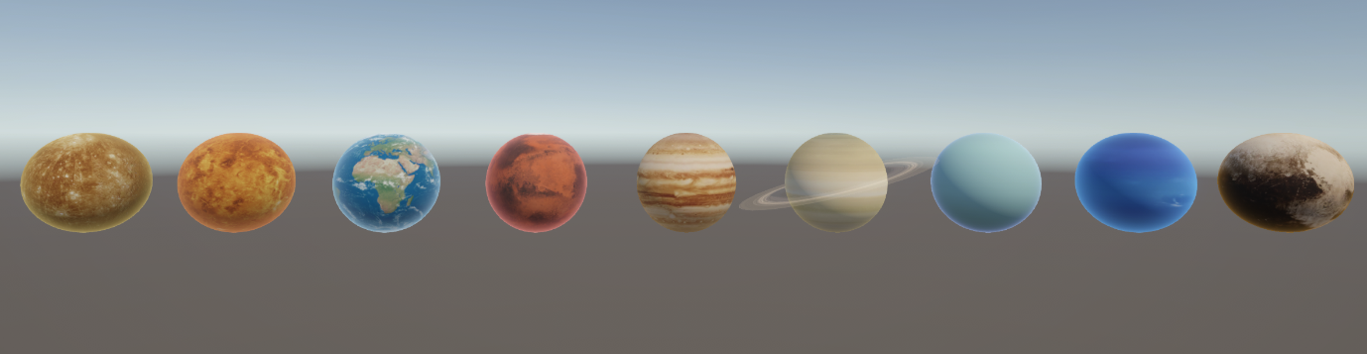

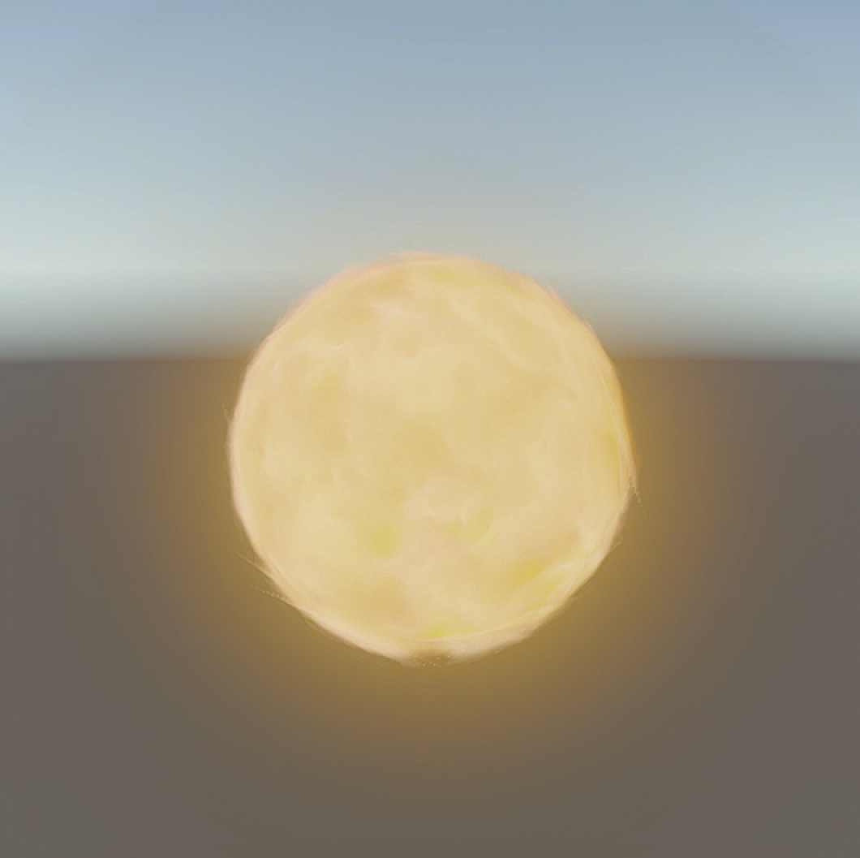*Sun Model:* This model is significantly larger to represent its scale compared to planets and serves as the centre of the solar system for orbit simulation.

*Asteroid Belt Model:* A particle system simulating the asteroid belt lends realism to the overall solar system, providing a more complete view of the solar system.

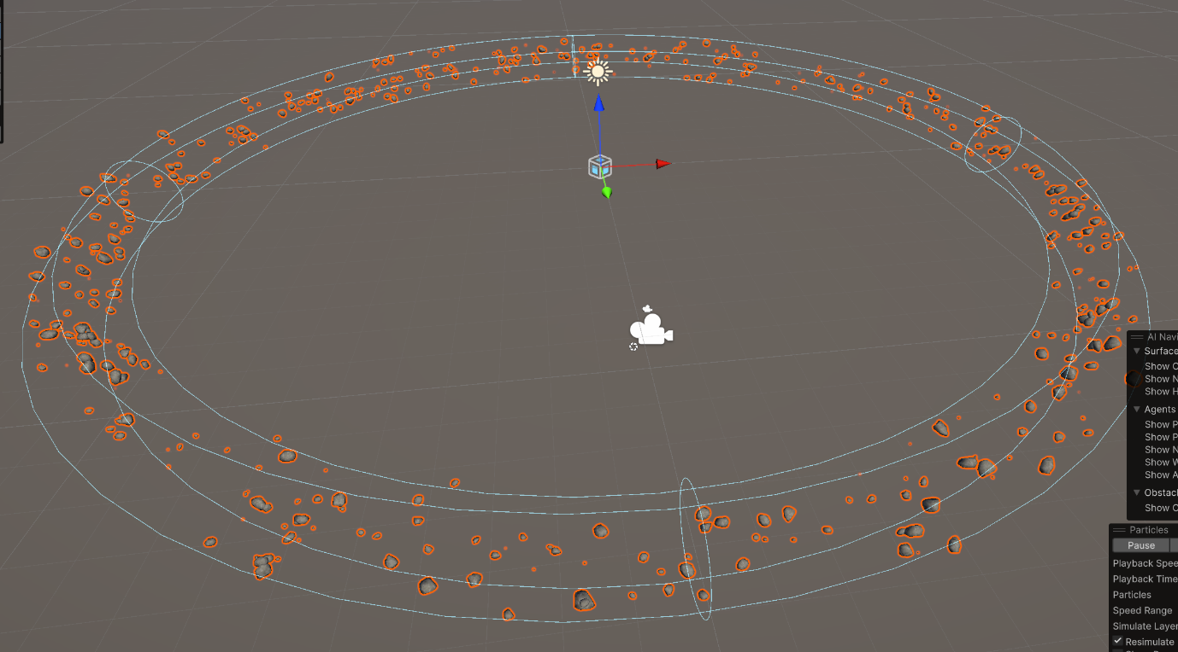

### References

Evgenii Nikolskii 2017, *Planets of the Solar System 3D*, Unity Asset Store, viewed 20 September 2024, <https://assetstore.unity.com/packages/3d/environments/planets-of-the-solar-system-3d-90219>